**COMP9331**

**Lab Exercise 3: DNS**

z5145114

Xiaodan Wang

**Exercise 3: Digging into DNS**

**Question 1**

The IP address of [www.cecs.anu.edu.au](http://www.cecs.anu.edu.au) is 150.203.161.98

Query type: A.

*$ dig www.cecs.anu.edu.au*

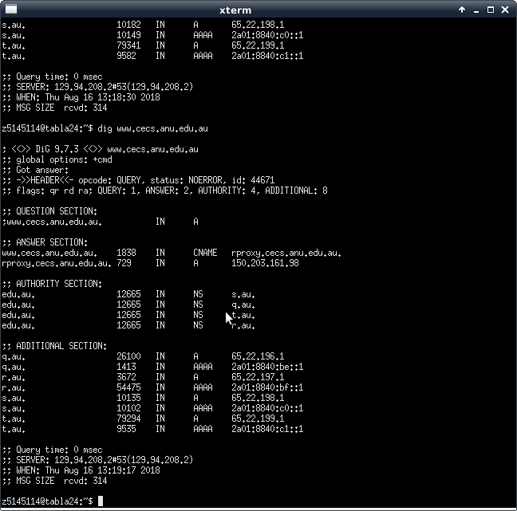

**Question 2**

The canonical name for CECS ANU web server is rproxy.cecs.anu.edu.au.

The IP address is 150.203.161.98.

Sometimes it is easier for clients to access the server with alias as they may access server with different name.

**Question 3**

In the rest response, there are authority and additional sections.

Authority section contains nameserver records.

Additional sections contains IPv4 and IPv6 address records.

**Question 4**

The IP address of the local nameserver for my machine is 129.94.208.2(port 53).

**Question 5**

The DNS nameservers for “cecs.anu.edu.au” are “ns2.cecs.anu.edu.au”, “ns3.cecs.anu.edu.au” and “ns4.cecs.anu.edu.au”.

“ns2.cecs.anu.edu.au”’s IP address is 150.203.161.36.

“ns3.cecs.anu.edu.au”’s IP address is 150.203.161.50.

“ns4.cecs.anu.edu.au”’s IP address is 150.203.161.38.

Query type: NS.

*$ dig cecs.anu.edu.au ns*

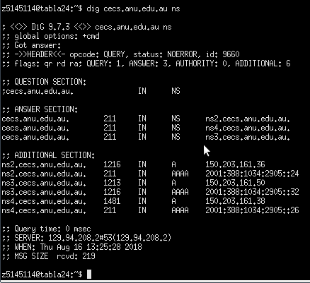

**Question 6**

The DNS name associated with the IP address 149.171.158.109 are “engplws008.ad.unsw.edu.au”, ”engplws008.eng.unsw.edu.au” and “www.engineering.unsw.edu.au”.

Query type: PTR.

*$ dig –x 149.171.158.109*

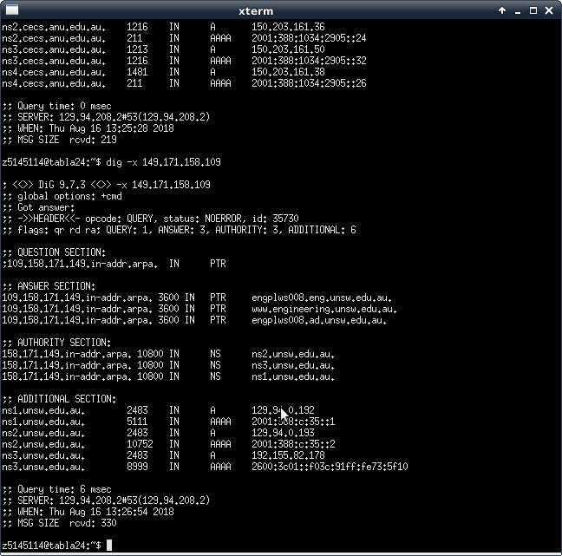

**Question 7**

No, I didn’t get an authoritative answer.

The flags show that there is not “aa” flag, which means there is no authoritative answer.

Also, it is easy to find that the answers are given by “mta6.am0.yahoodns.net”, “mta6.am0.yahoodns.net” and “mta6.am0.yahoodns.net”. None of them are authority server.

*$ dig @129.94.242.33 yahoo.com mx*

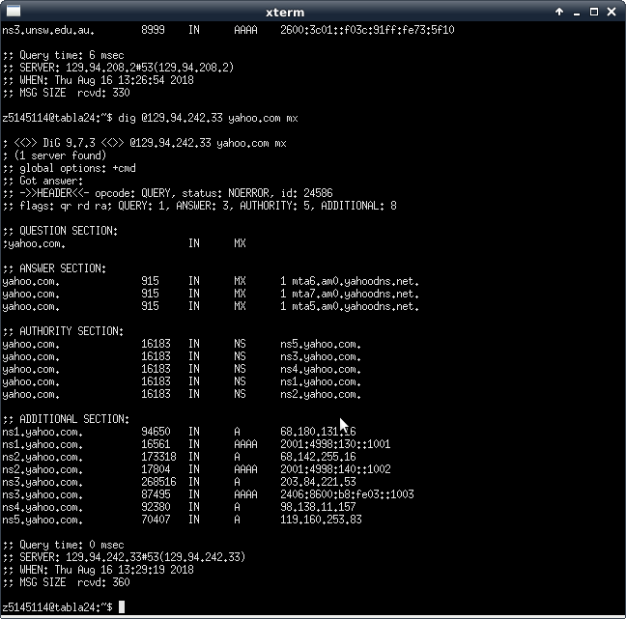

**Question 8**

Get 0 answer. The query is refused.

*$ dig @150.203.161.36 yahoo.com mx*

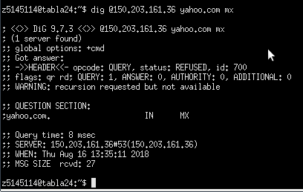

**Question 9**

First, get the nameserver of Yahoo!Mail.

Then, query the Yahoo!Mail with authority nameserver.

Query type: NS, A.

*$ dig yahoo.com ns*

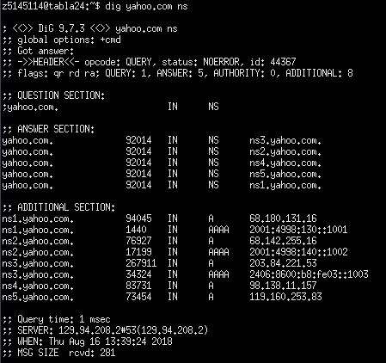

*$ dig @ns2.yahoo.com yahoo.com*

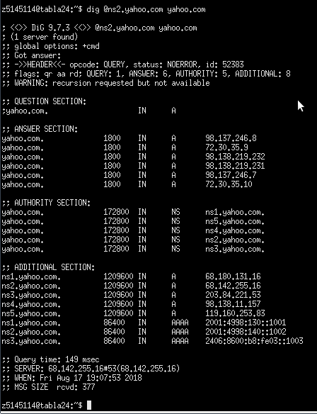

**Question 10**

It takes 6 steps.

Step 1:

*$ dig . ns*

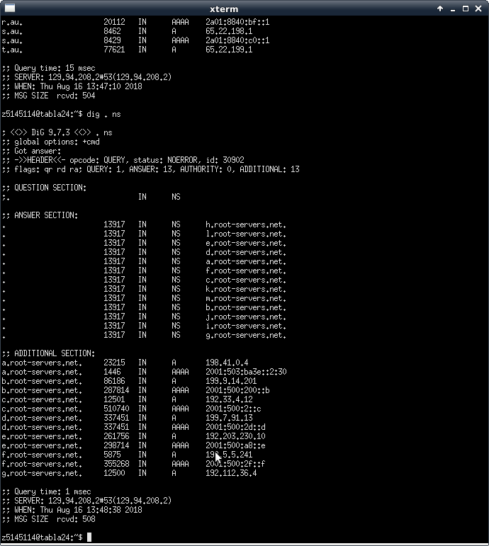

Step 2:

*$ dig @h.root-servers.net. .au ns*

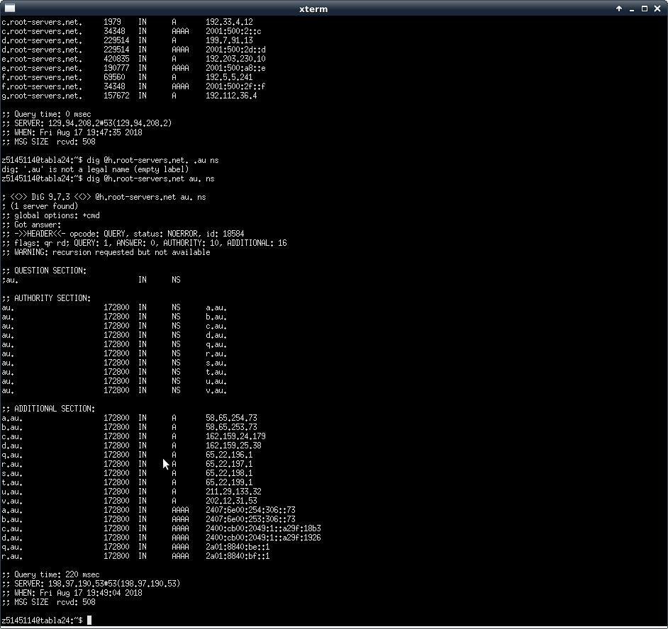

Step 3:

*$ dig @a.au edu.au ns*

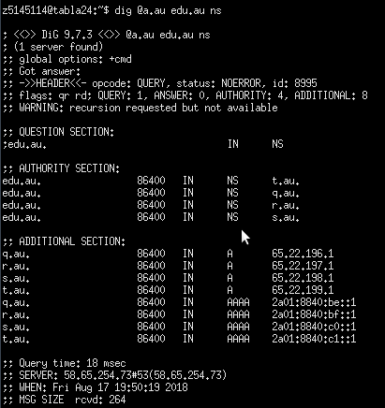

Step 4:

*$ dig @t.qu unsw.edu.au ns*

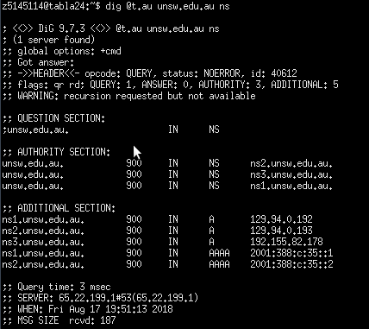

Step 5:

*$ dig @ns2.unsw.edu.au cse.unsw.edu.au ns*

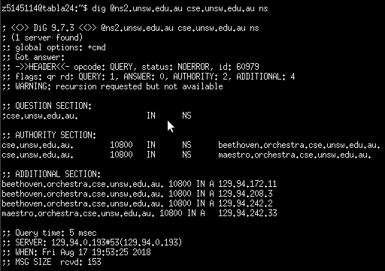

Step 6:

*$ dig @beethoven.orchestra.cse.unsw.edu.au tabla24.orchestra.cse.unsw.edu.au*

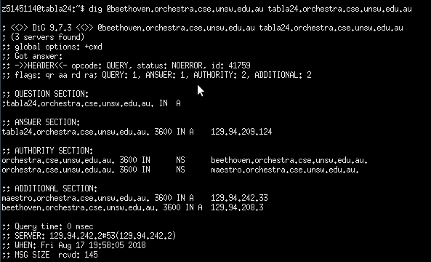

**Question 11**

One physical machine can have several names associated with it but only one IP address.

**Exercise 4: A Simple Web Server**

The results of WebServer.py is shown below.

1. HTML file

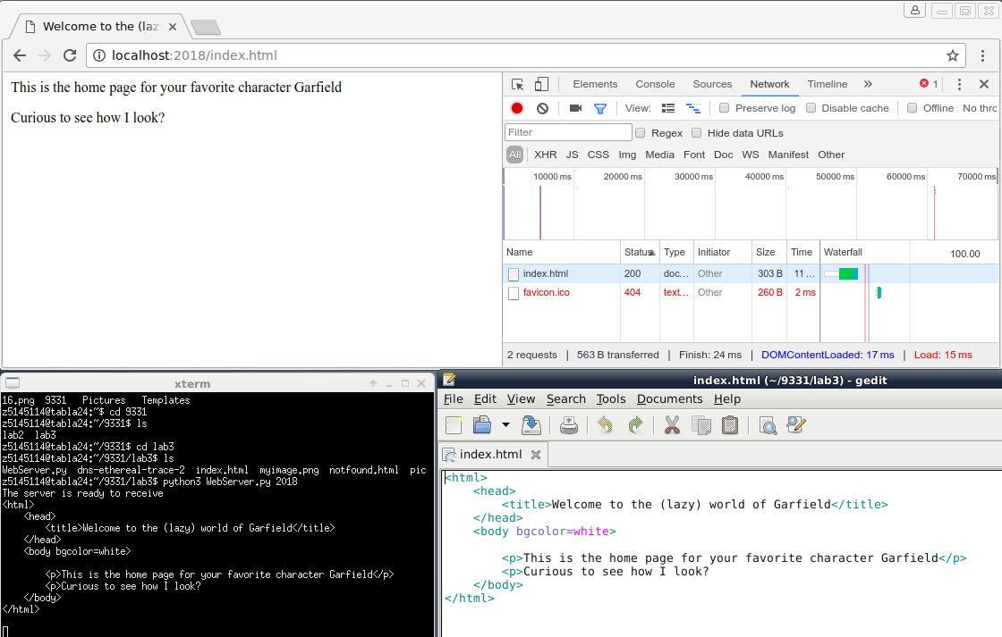

2. Image files

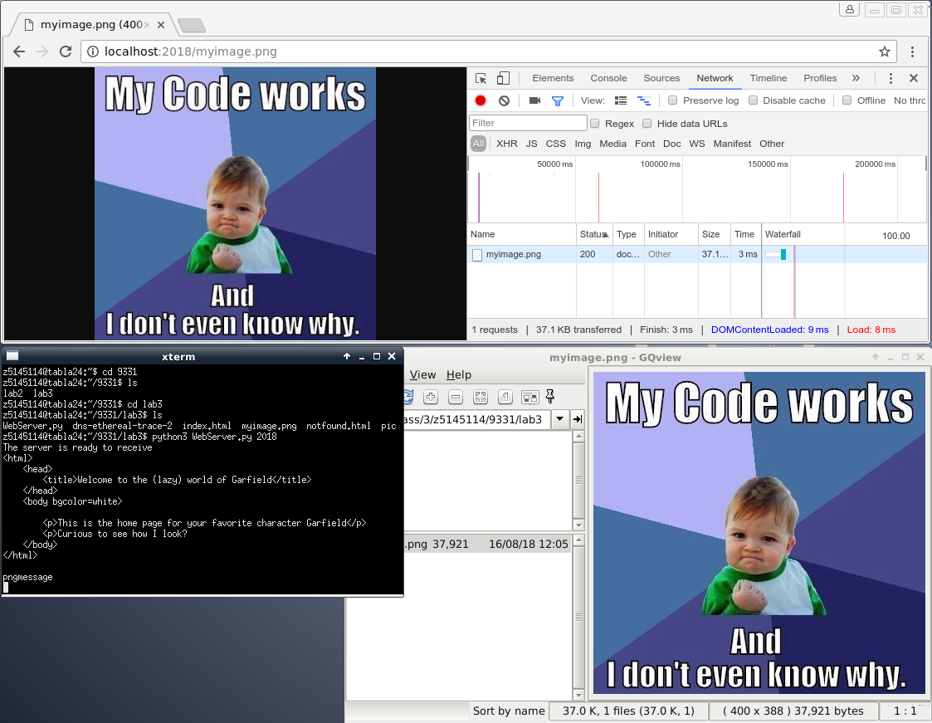

3. None exist object

